GÖTÜR Project

Use Cases and Use Case Model

Version 1.1

Prepared By:

MESE Company

Revision History

|  |  |  |  |
| --- | --- | --- | --- |
| **Date** | **Version** | **Description** | **Author** |
| 02/04/2022 | 1.0 | Draft 1 | MESE TEAM |
| 09/04/2022 | 1.1 | Corrections are made based on review:   * Preconditions and Success Guarantees are added for fully dressed use cases * System failure scenario is added for fully dressed use cases * External actor “Authentication System” is added to use case model (for possible Google and Facebook integrations) | MESE TEAM |

# Use Case Model

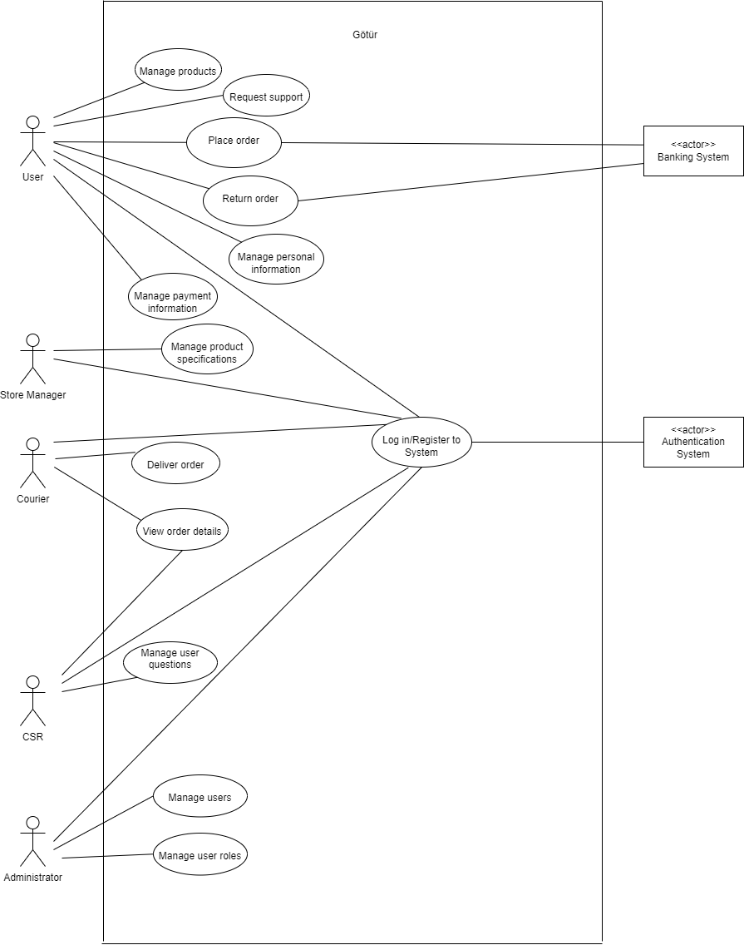

# All Roles

## Use Case UC1: Register to System

User wants to register to system. System displays registration form. User enters name, phone number and e-mail. User clicks on register. System sends an e-mail to user to activate account. User accepts invitation. System completes registration.

## Use Case UC2: Log in to System

User wants to log in to system. System displays log in page. User enters e-mail and clicks on log in. System allows user to log in.

# User Scenarios

## Use Case UC1: Manage Products

**Scope:** Götür Application

**Level:** User Goal

**Primary Actor:** User

**Preconditions:** User successfully logged in to the system.

**Main Success Scenario:**

1. User wants to manage products.
2. System presents the product list alphabetically and shows related prices.
3. User adds product(s) to basket.

User repeats step 3 until indicates done.

1. System updates the inventory and displays added items in the basket.

**Extensions:**

**\*a.** At any time, system fails:

1. System displays an error message.
2. User restarts the system.
3. System redirects the user to the last saved page.

**2a.** User wants to filter products.

1. System displays search bar in the main page.
2. User filters the products by keyword.
3. System displays products based on filter.
4. Go to step 3 of the main success scenario.

**3a.** User wants to remove products.

1. System displays items in the basket.
2. User selects items to remove and clicks on delete.
3. System updates the inventory.

**3b.** User wants to update number of products.

1. System displays items in the basket.
2. User updates the number of the related product.
3. System updates the inventory.

**Success Guarantees:**

Inventory is updated. Items in the basket are displayed to User.

## Use Case UC2: Place Order

**Scope:** Götür Application

**Level:** User Goal

**Primary Actor:** User

**Preconditions:** User successfully logged in to the system.

**Main Success Scenario:**

1. User wants to place order.
2. System displays user’s basket page.
3. User selects proceed to payment.
4. System lists the payment methods (previously saved card information).
5. User selects the credit/bank card that he/she wants to proceed.
6. System presents the shipping cost and the total cost.
7. User accepts the terms and conditions.
8. System saves the order information and sends the order notification to courier.

**Extensions:**

**\*a.** At any time, system fails:

1. System displays an error message.
2. User restarts the system.
3. System redirects the user to the last saved page.

**2a.** User wants to filter products.

1. System displays search bar in the main page.
2. User filters the products by keyword.
3. System displays products based on filter.
4. Go to step 3 of the main success scenario.

**Success Guarantees:**

Order is saved and notification is sent to Courier.

## Use Case UC3: Return order

User wants to return order. System lists previous orders of the user. User selects the order. System presents order details page. User clicks on return order. System shows return reasons. User selects a reason and confirms return order. System sends an in-app notification to Courier. System starts the refund process.

## Use Case UC4: Manage Personal Information

**Scope:** Götür Application

**Level:** User Goal

**Primary Actor:** User

**Preconditions:** User successfully logged in to the system.

**Main Success Scenario:**

1. User wants to manage user information.
2. System displays profile information (phone number, name, e-mail, address fields).
3. User configures information and clicks on save.
4. System saves the updates.

**Extensions:**

**\*a.** At any time, system fails:

1. System displays an error message.
2. User restarts the system.
3. System redirects the user to the last saved page.

**3a.** There is a mistaken field in the data entered by the user.

1. System displays an error message.
2. User selects try again.
3. Go to step 3 of the main success scenario.

**Success Guarantees:**

User’s profile information update is successfully saved by the system.

## Use Case UC5: Manage Payment Information

**Scope:** Götür Application

**Level:** User Goal

**Primary Actor:** User

**Preconditions:** User successfully logged in to the system.

**Main Success Scenario:**

1. User wants to manage payment information.
2. System displays payment information page.
3. User adds credit card information.
4. System saves the updates.

User repeats steps 3-4 until indicates done.

**Extensions:**

**\*a.** At any time, system fails:

1. System displays an error message.
2. User restarts the system.
3. System redirects the user to the last saved page.

**3a.** There are missing digits in card information.

1. System displays an error message.
2. User selects confirm to try again.
3. System re-opens payment information page.

**3b.** User wants to remove card.

1. System displays payment information page.
2. User selects card(s) to remove and clicks on delete.
3. Go to step 4 of the main success scenario.

**Success Guarantees:**

Payment information is successfully saved.

## Use Case UC6: Request Support

User wants to request customer support about the order. System opens dialogue box. User asks question to Customer Sale Representative. System sends the message to CSR. User selects to finish conversation. System saves the messages.

# Store Manager Scenarios

## Use Case UC1: Manage Product Specifications

Store Manager wants to manage product specifications. System displays product specifications page. Store Manager updates the product inventory, price information and name of the product(s) and clicks on save. System saves the changes.

# Courier Scenarios

## Use Case UC1: View Order Details

Courier wants to view order details. System displays users. Courier selects a user. System presents orders belong to that user. Courier selects an order. System displays order details page.

## Use Case UC2: Deliver Order

Courier wants to deliver order. System displays order details page (details of the products and the delivery address). Courier changes the order status to in progress. System updates the order status. Courier delivers the order to customer and changes the status to delivered. System saves the changes.

# CSR Scenarios

## Use Case UC1: Manage User Questions

CSR wants to manage user questions. System displays questions page. CSR gives the answer. System sends the response to user (repeat last three steps). CSR selects to finish conversation. System saves the messages.

## Use Case UC2: View Order Details

CSR wants to view order details of a user. System displays users. CSR selects a user. System presents orders belong to that user. CSR selects an order. System displays order details page.

# Admin Scenarios

## Use Case UC1: Manage Users

Admin wants to manage users. System displays users page. Admin updates user’s basic information. System saves the updates.

## Use Case UC2: Manage User Roles

Admin wants to manage user roles. System displays roles page. Admin matches user with related role and clicks on save. System saves the updates.